Experiment-24
Aim:
To model clock-driven concurrent processes using SC_THREAD and wait() in SystemC.
Code:
//exp:24
//Name:Sadhana.V
//roll no:192565042
//class:ECA1408 Embedded System
#include <systemc.h>

SC_MODULE(ClockExample) {
sc_in<bool> clk;

void process() {
while (true) {
wait();
std::cout << "Time: " << sc_time_stamp()
<< " - Clock Triggered" << std::endl;
}
}

SC_CTOR(ClockExample) {
SC_THREAD(process);
sensitive << clk.pos();

}
};

int sc_main(int argc, char* argv[]) {

sc_clock clock("clock", 1, SC_NS);

ClockExample module("module");
module.clk(clock);

sc_start(5, SC_NS);

return 0;
}
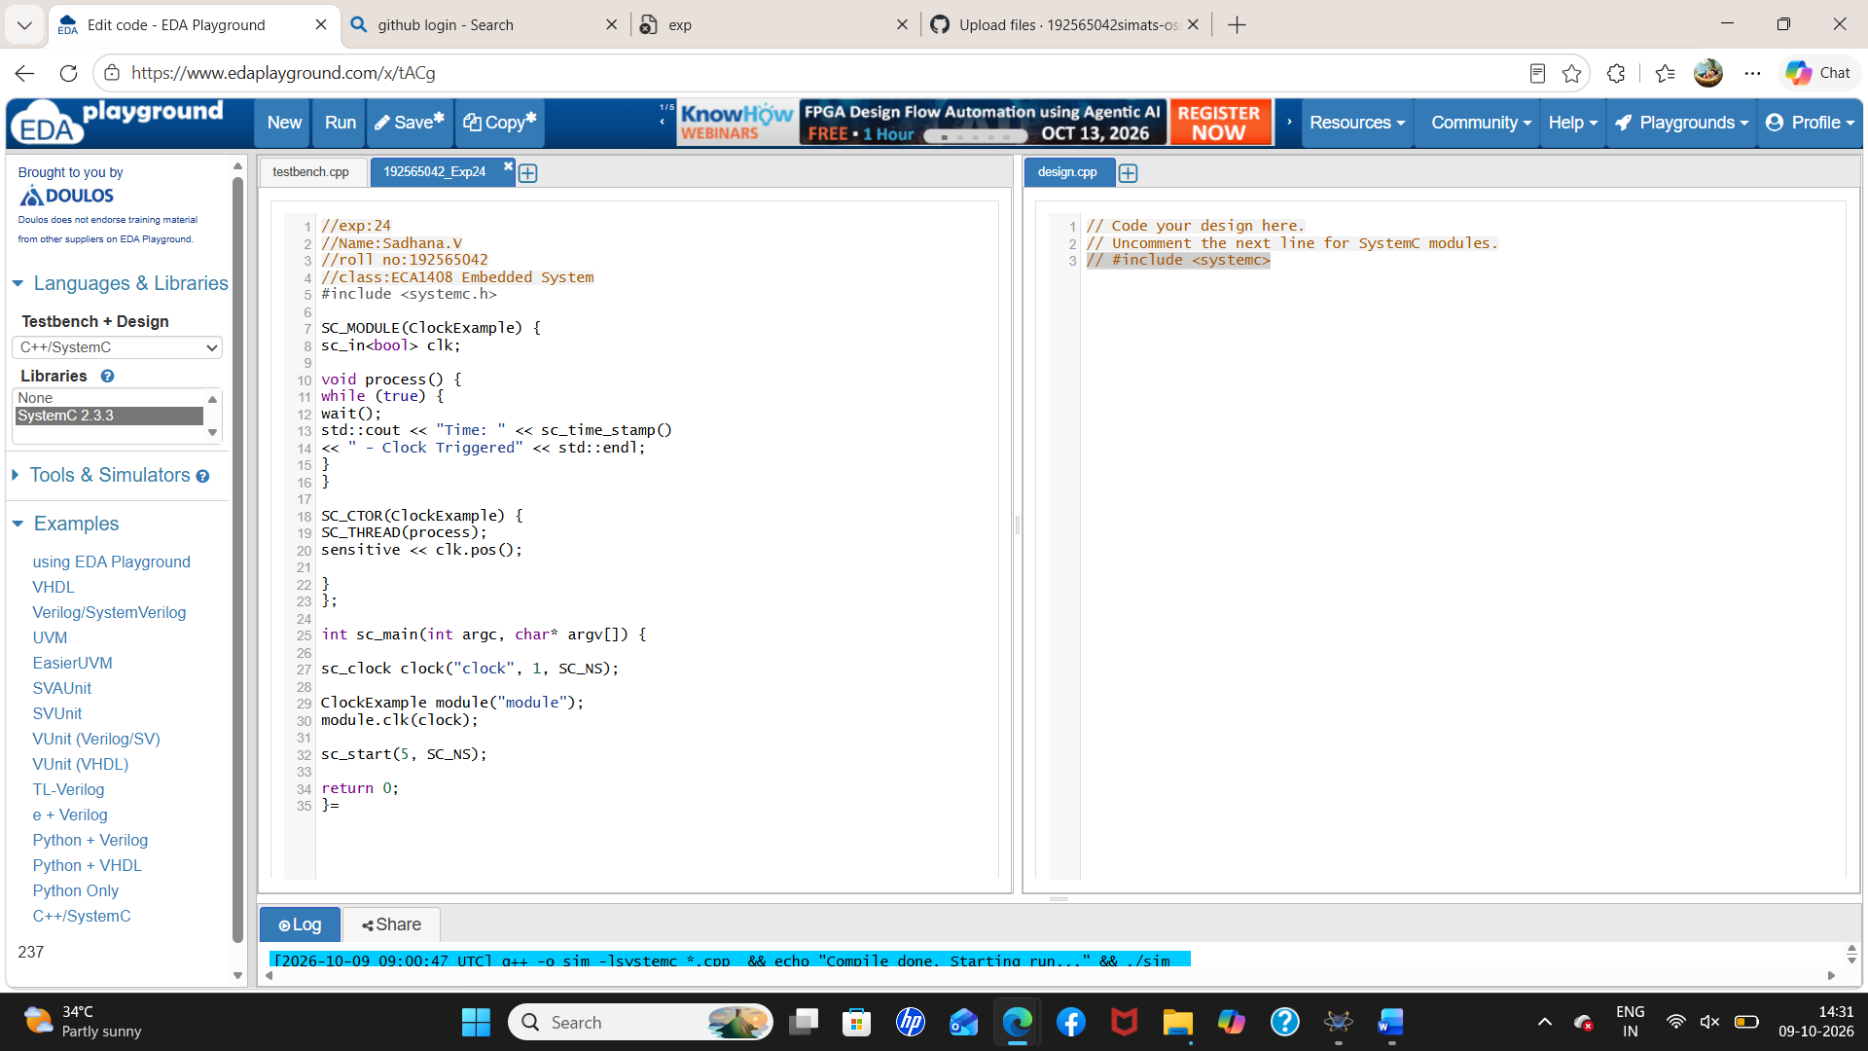
Output
